Task: Creating a Simple Shopping List Application in C#

Description:

You are tasked with creating a basic shopping list application in C#. The application should allow users to add items to a shopping list, display the list of items, and provide information about whether a certain item has been added or not. Implement the application using Lists and utilize if-else statements for conditional checks.

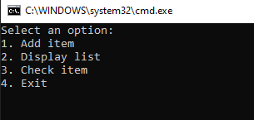

Use switch case and arraylist )))